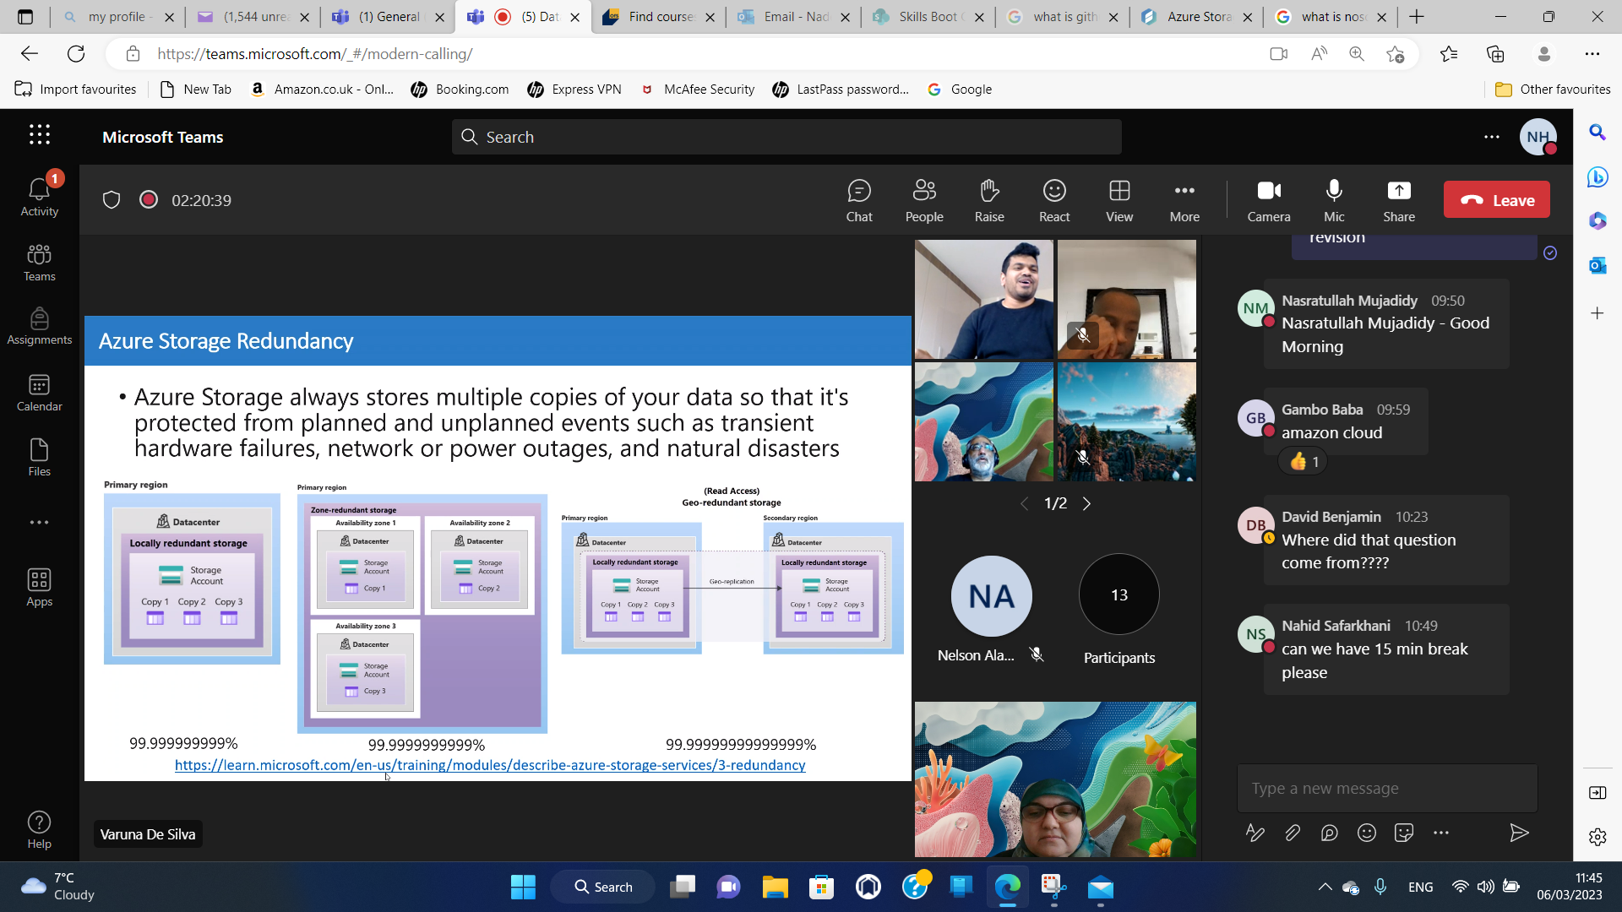

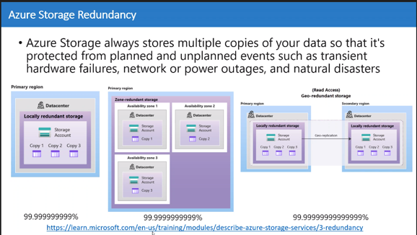

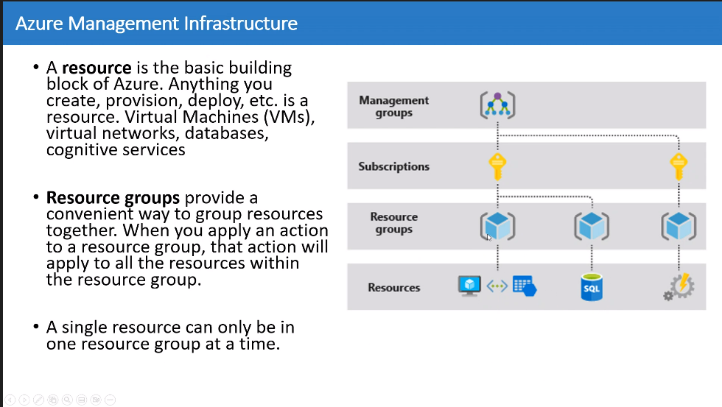

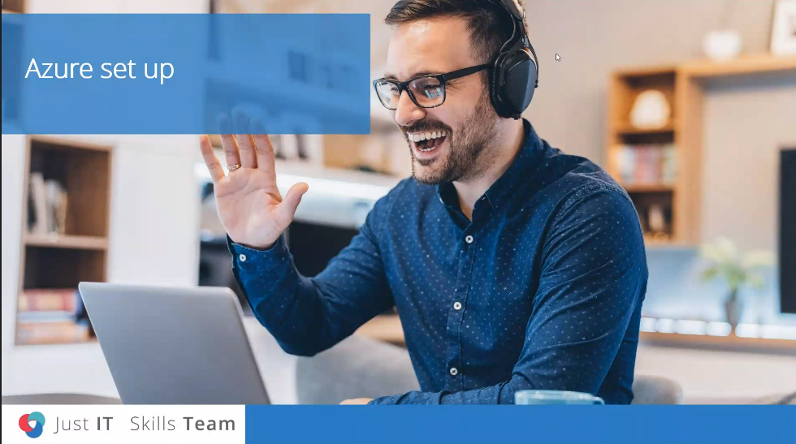

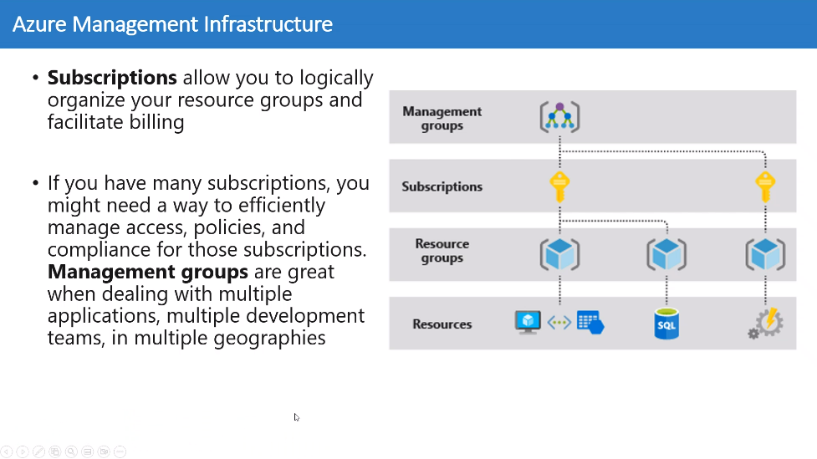

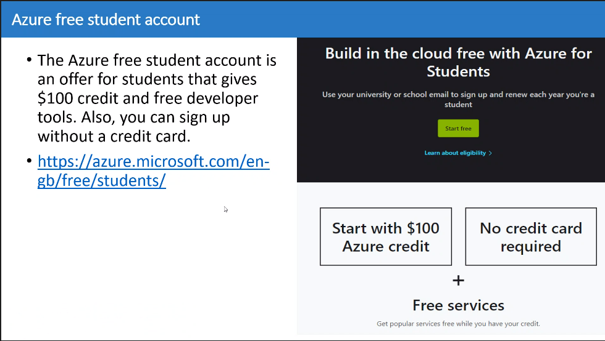

[Azure Fundamentals: Describe Azure architecture and services - Training | Microsoft Learn](https://learn.microsoft.com/en-us/training/paths/azure-fundamentals-describe-azure-architecture-services/)

This link prepare us for the exam

[Home - Microsoft Azure](https://portal.azure.com/#home) to open the azure account

Skillable link

<https://alh.learnondemand.net/User/Login>

Training website AZURE

[Azure Fundamentals: Describe Azure architecture and services - Training | Microsoft Learn](https://learn.microsoft.com/en-us/training/paths/azure-fundamentals-describe-azure-architecture-services/)

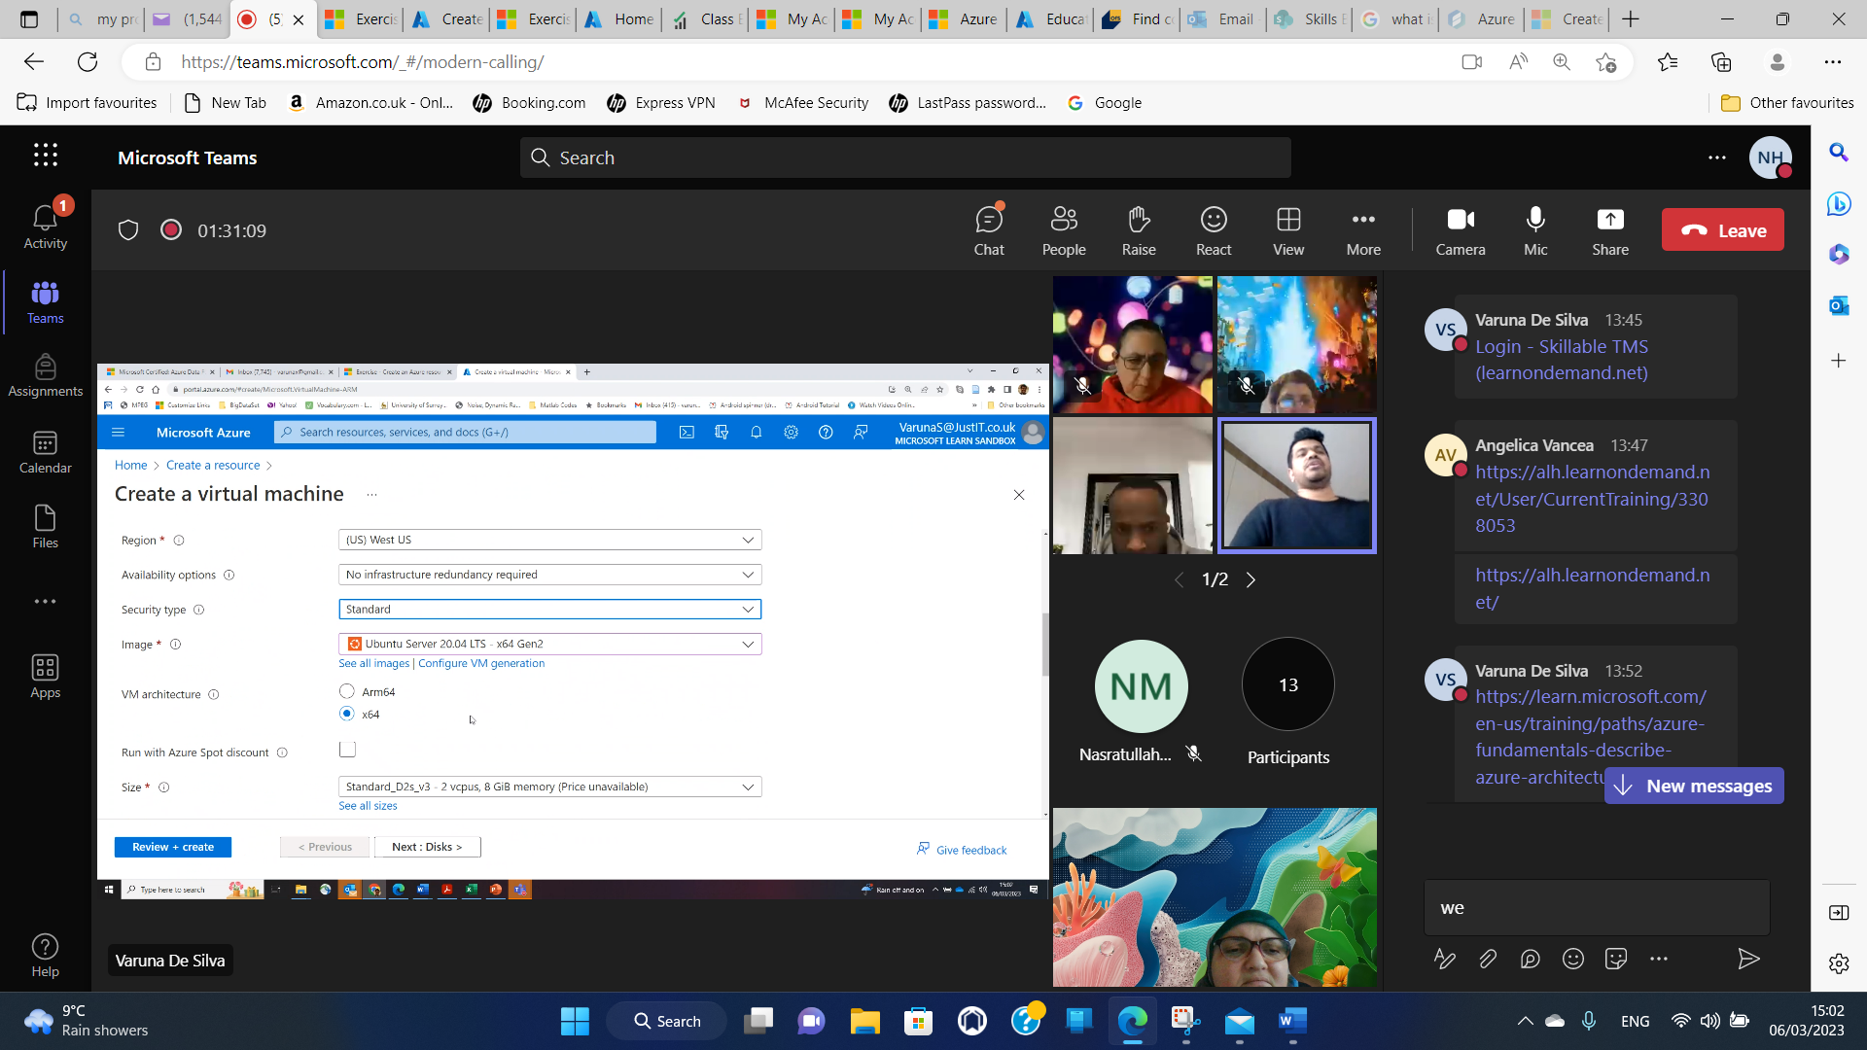

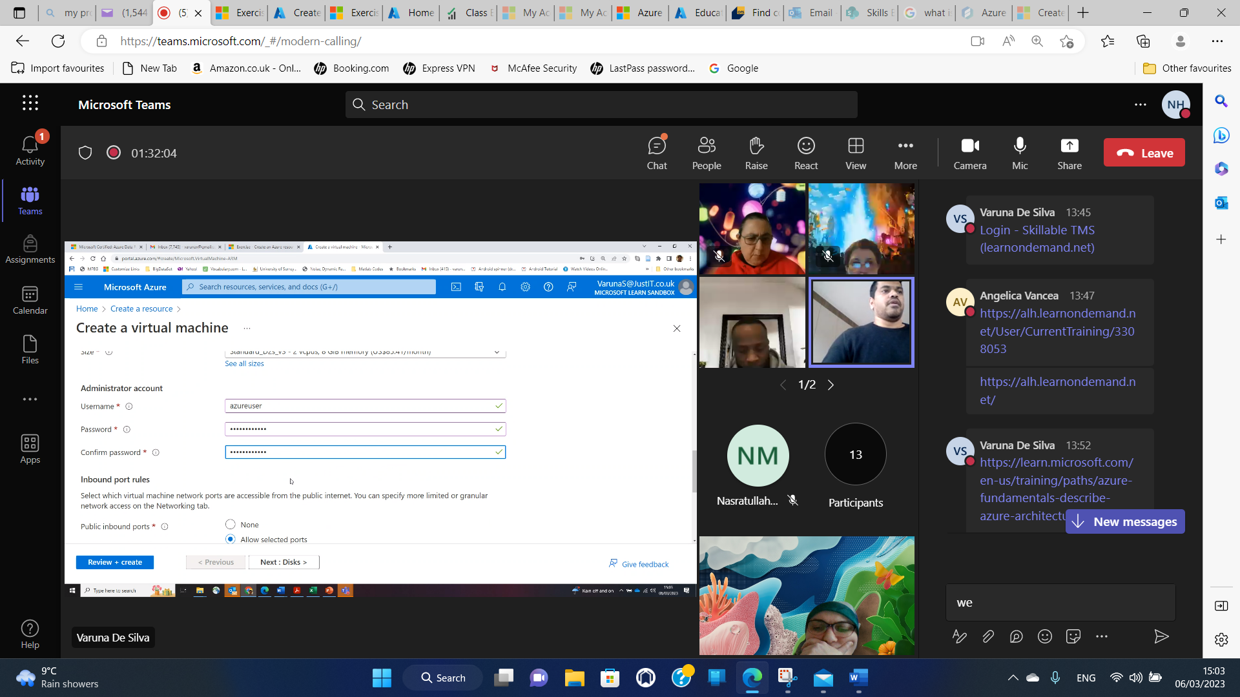

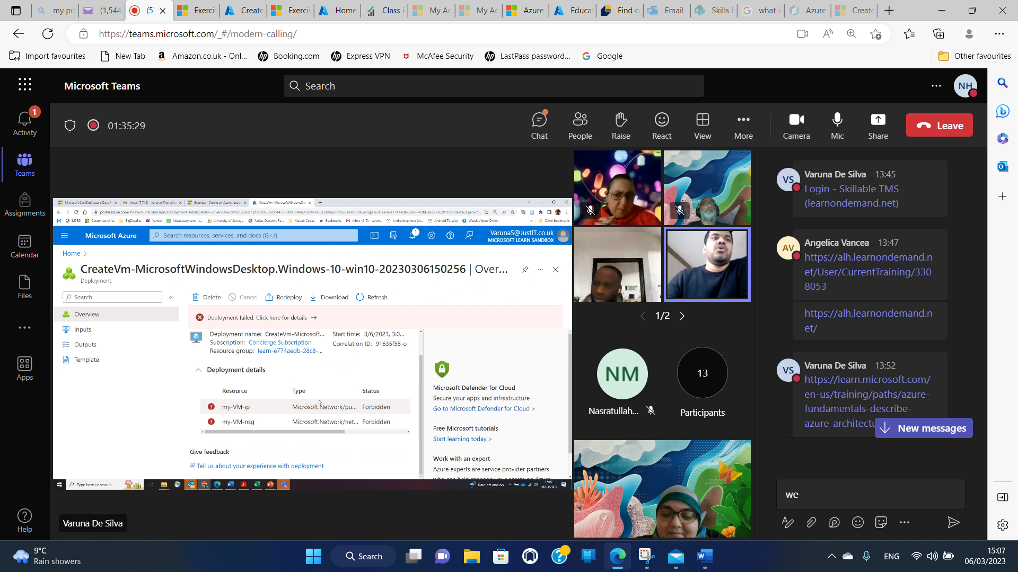

[Class Enrollment: Nadera Hellel, DP-900T00-A Microsoft Azure Data Fundamentals [No Azure Pass Required] (Vinita GLA3) - Skillable TMS (learnondemand.net)](https://alh.learnondemand.net/ClassEnrollment/3513717)

Skillable Account

<https://learn.microsoft.com/en-us/training/paths/azure-fundamentals-describe-azure-architecture-services/>

this link helps us to go AZURE ACCOUNT AND COURSE

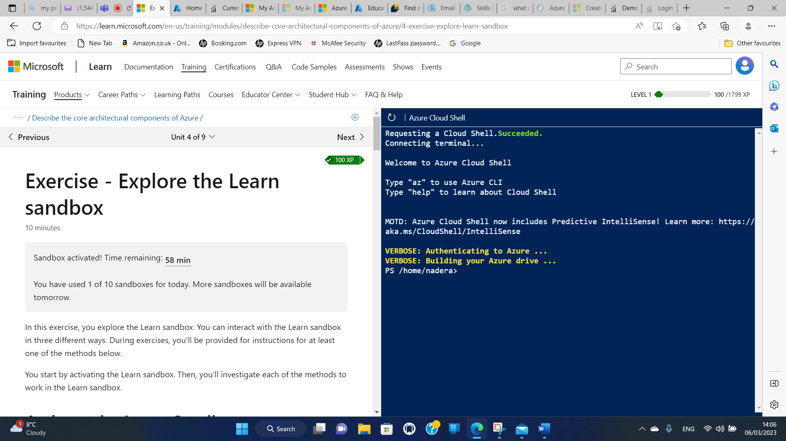

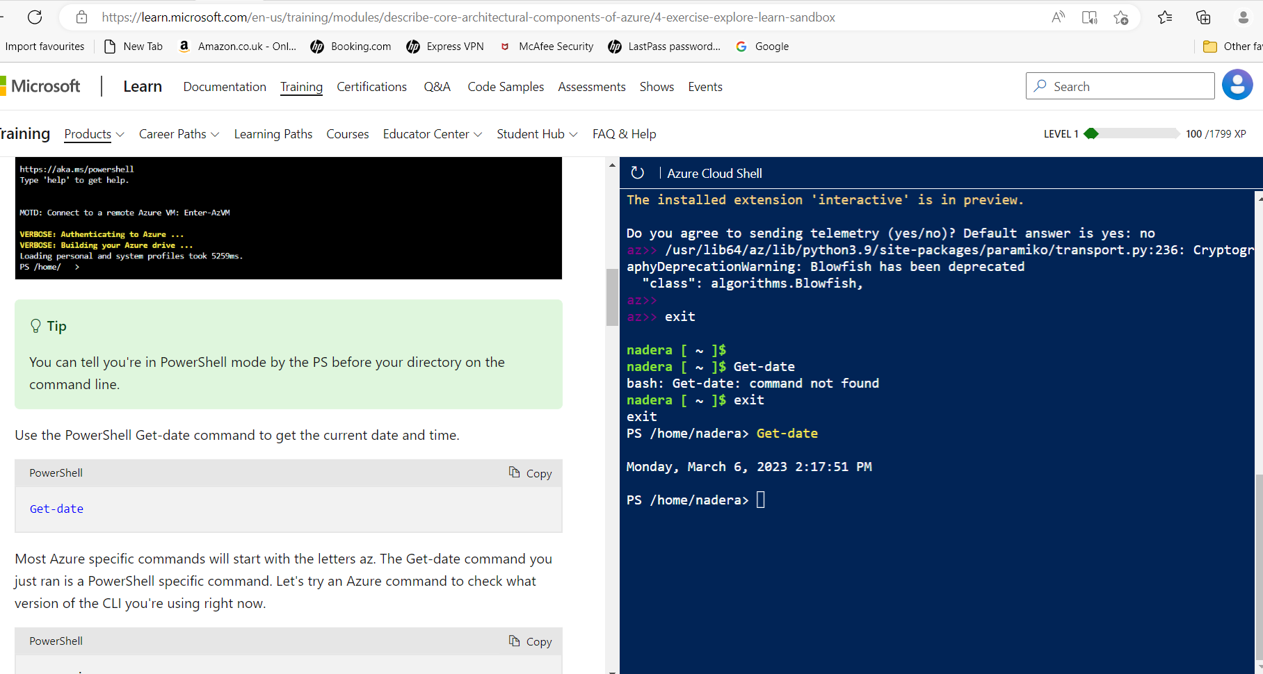

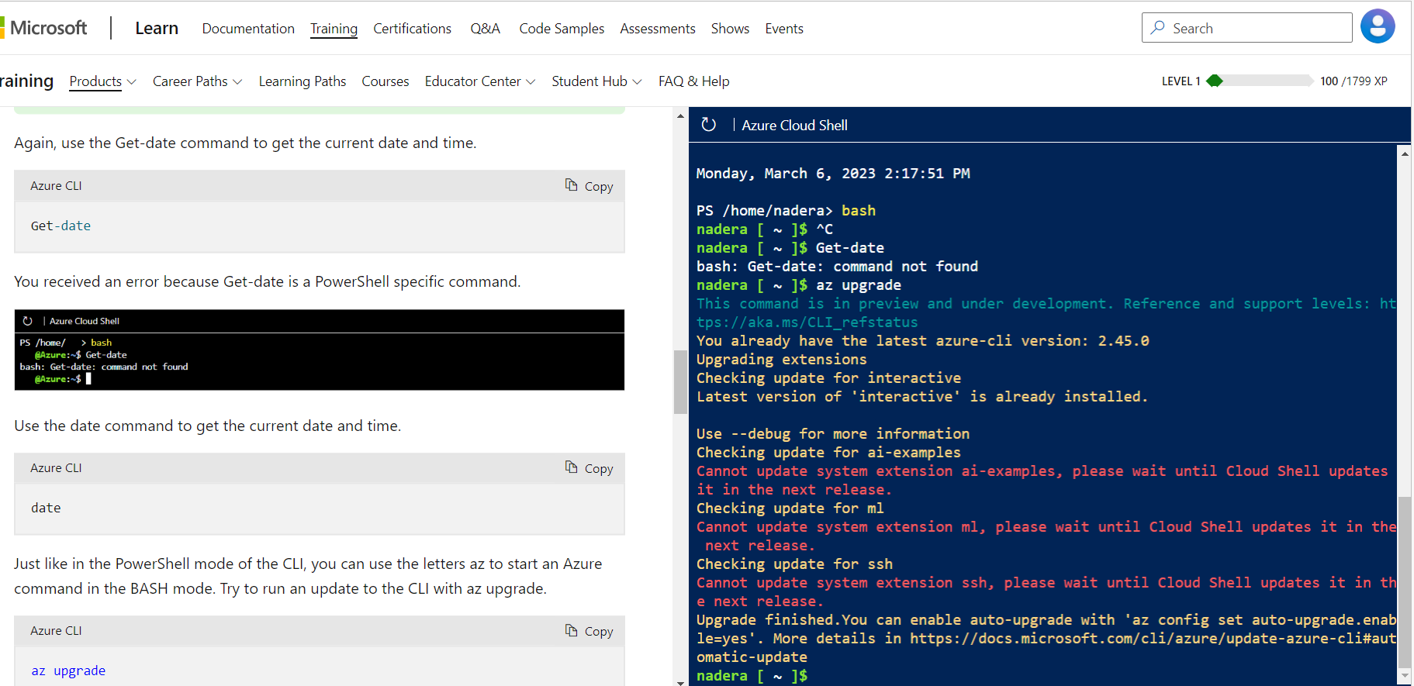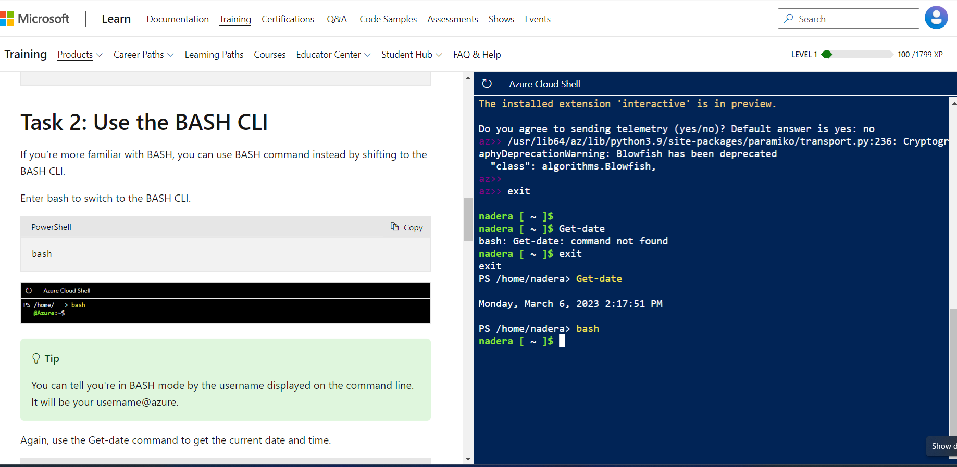

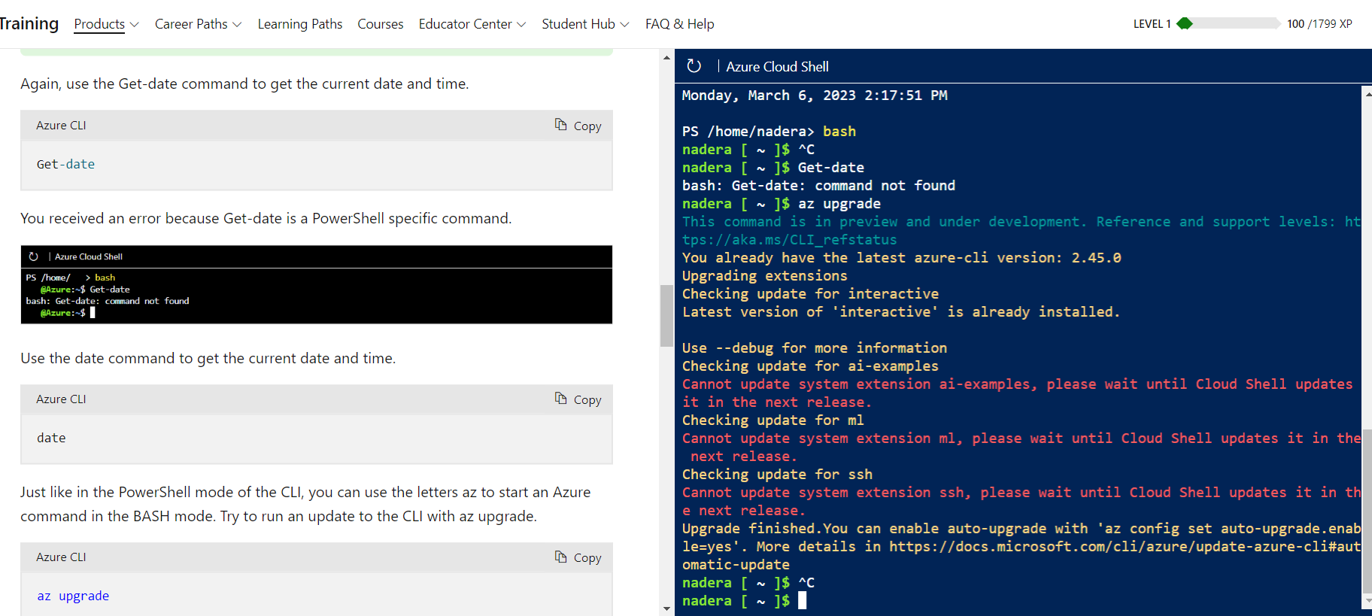

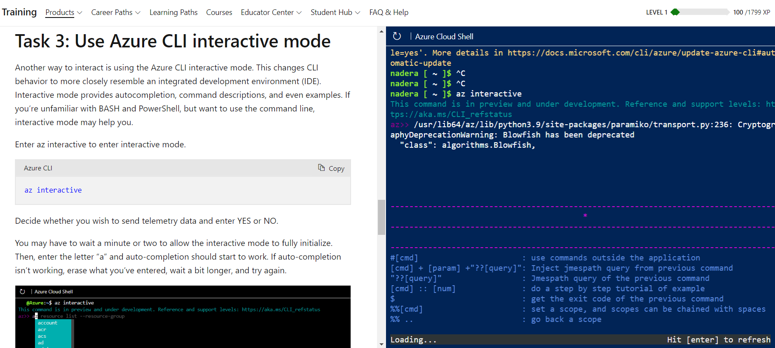

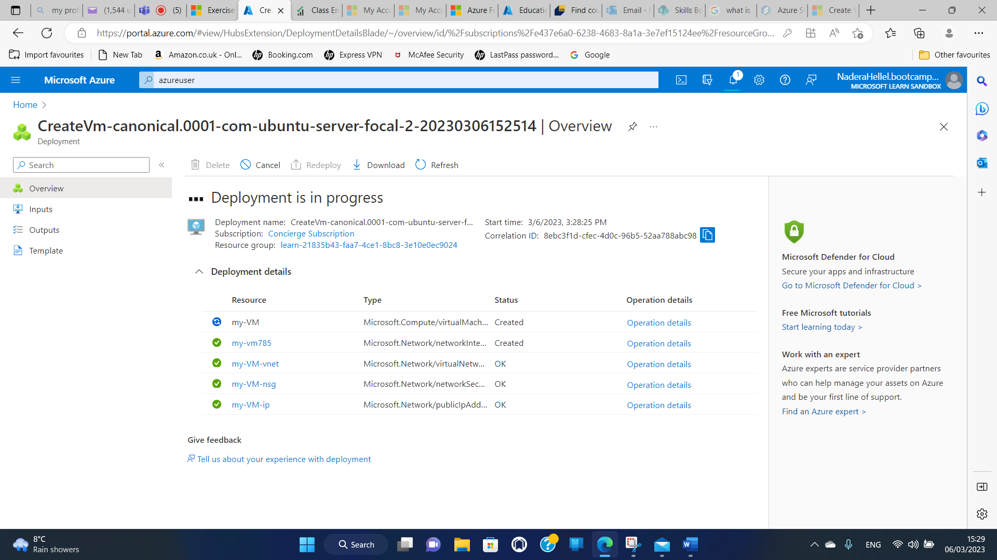

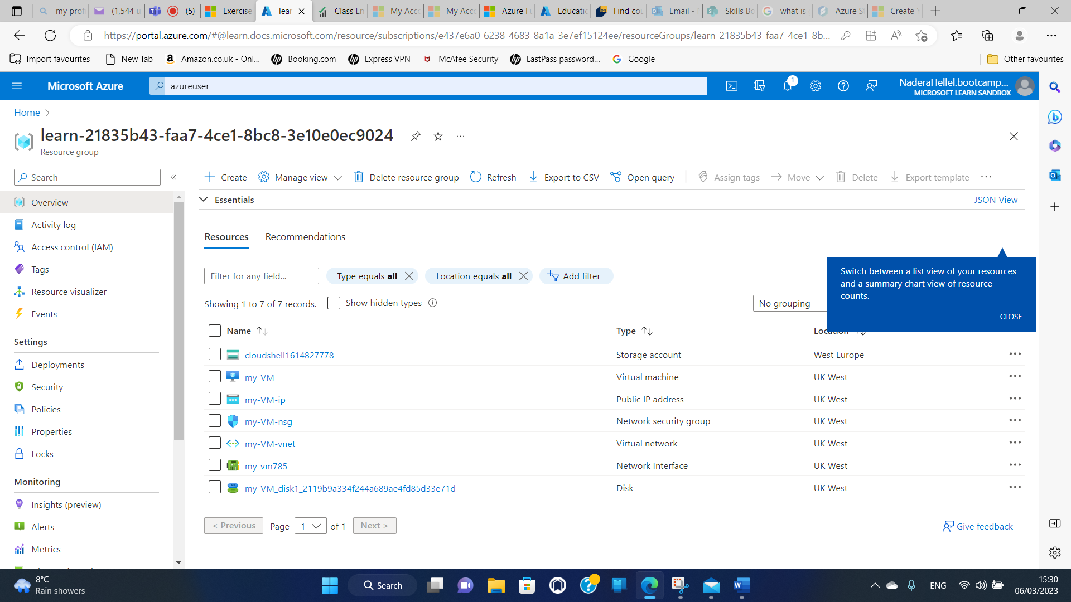

Step1

https://learn.microsoft.com/en-gb/training/modules/describe-core-architectural-components-of-azure/4-exercise-explore-learn-sandbox

Step2

https://learn.microsoft.com/en-gb/training/modules/describe-core-architectural-components-of-azure/7-exercise-create-azure-resource

Step3

https://learn.microsoft.com/en-gb/training/modules/describe-azure-storage-services/5-exercise-create-storage-blob

to do 03 steps I did 1

This link possede les exercises 3

[Describe Azure storage services - Training | Microsoft Learn](https://learn.microsoft.com/en-us/training/modules/describe-azure-storage-services/)

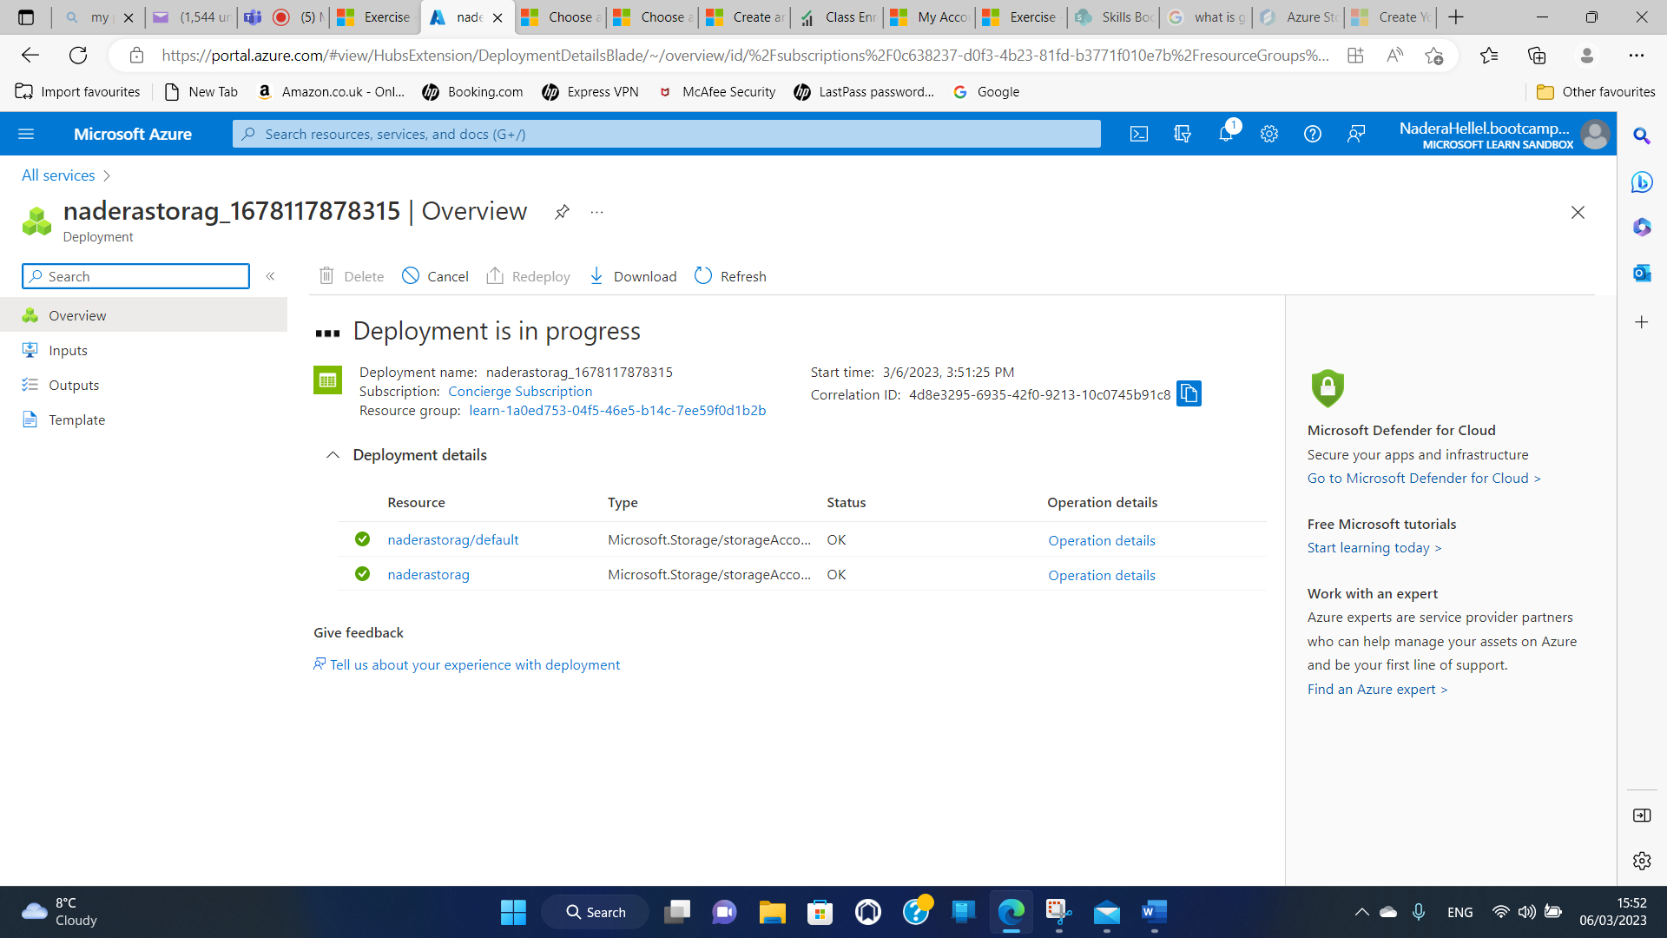

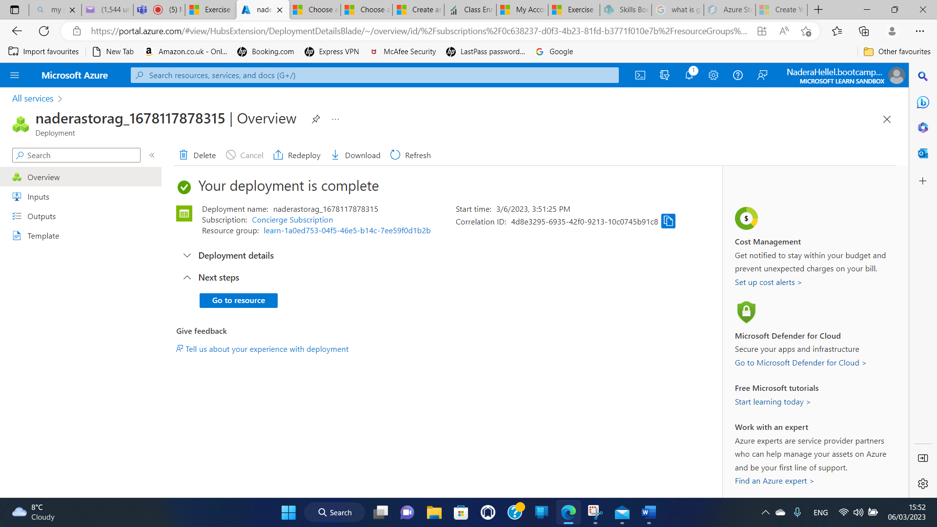

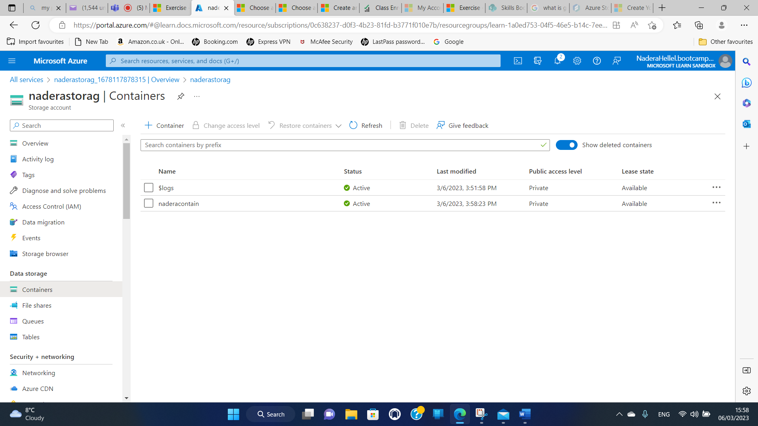

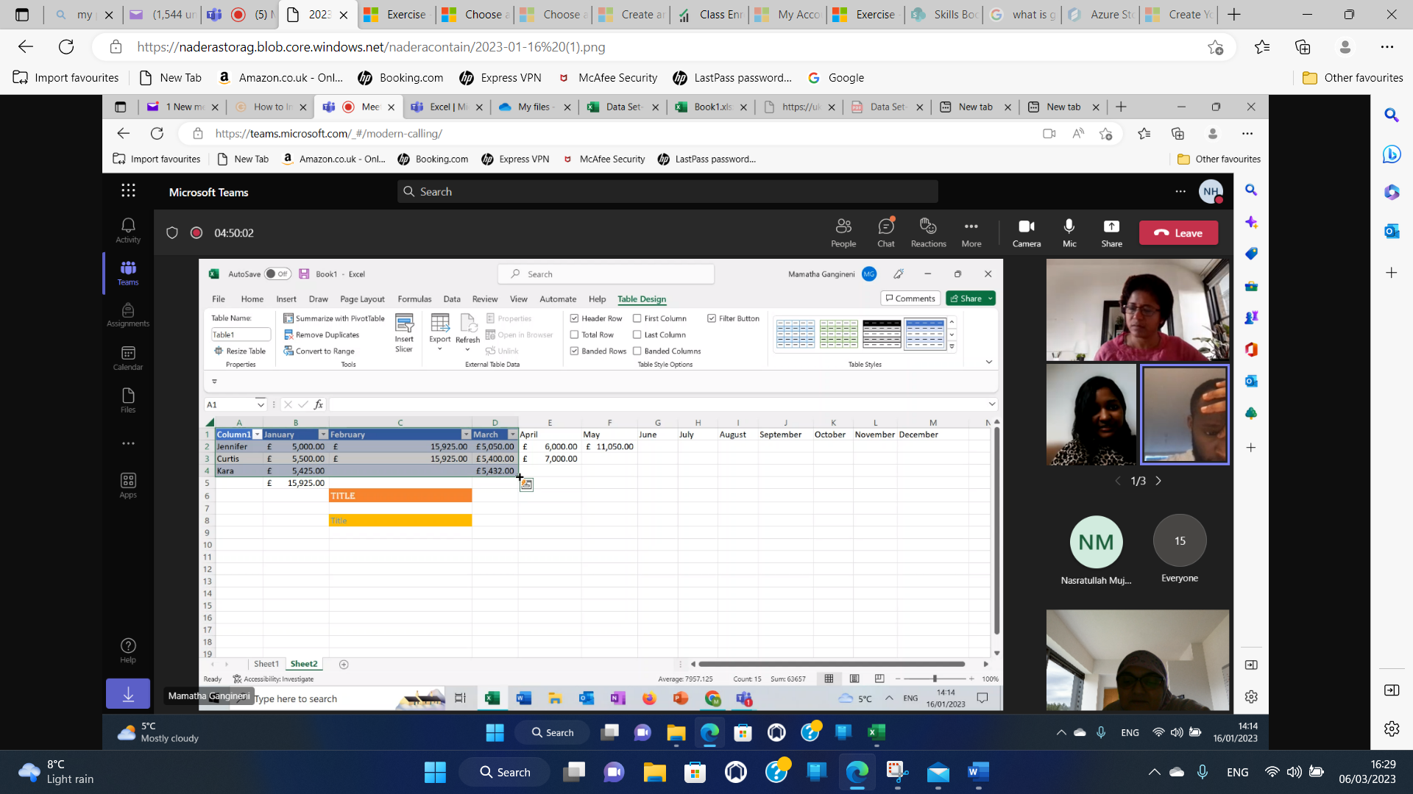

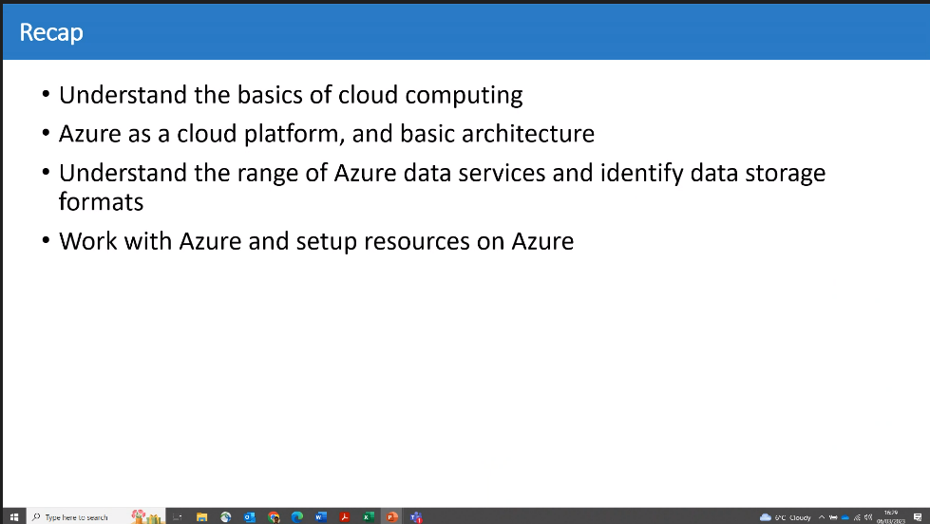

https://learn.microsoft.com/en-gb/training/paths/azure-fundamentals-describe-azure-architecture-services/

this link for training and revision

https://labclient.labondemand.com/LabClient/b7f51c25-63a6-43d5-8a87-3a058fad85a1?rc=10

it is skillable link

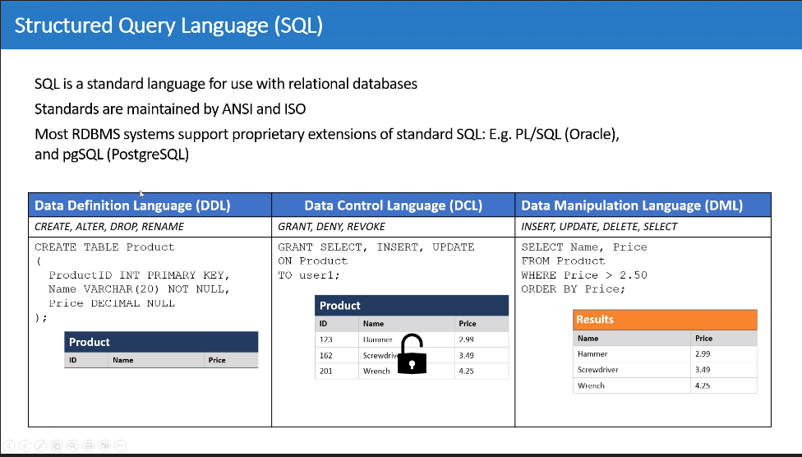

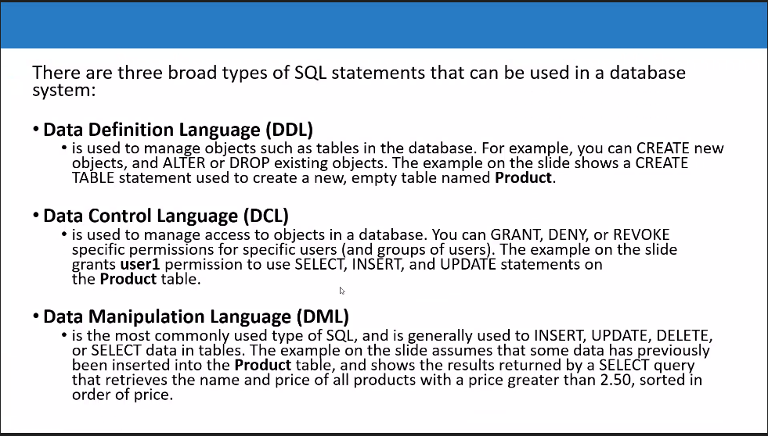

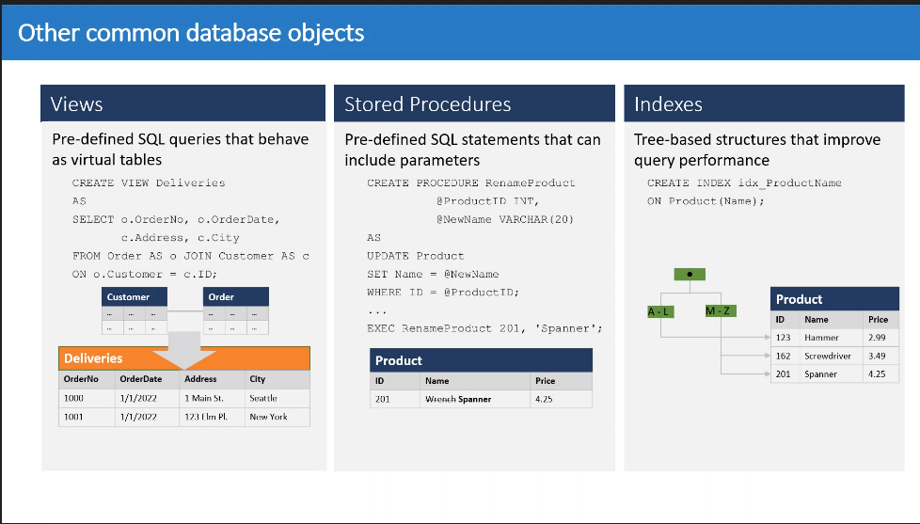

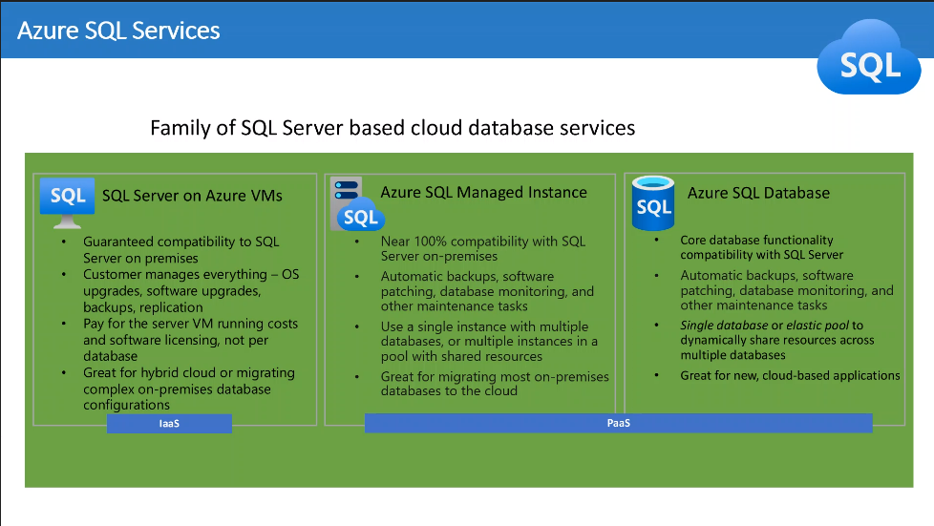 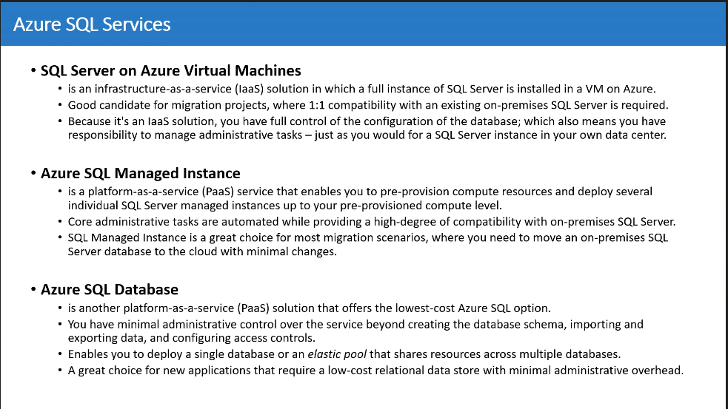

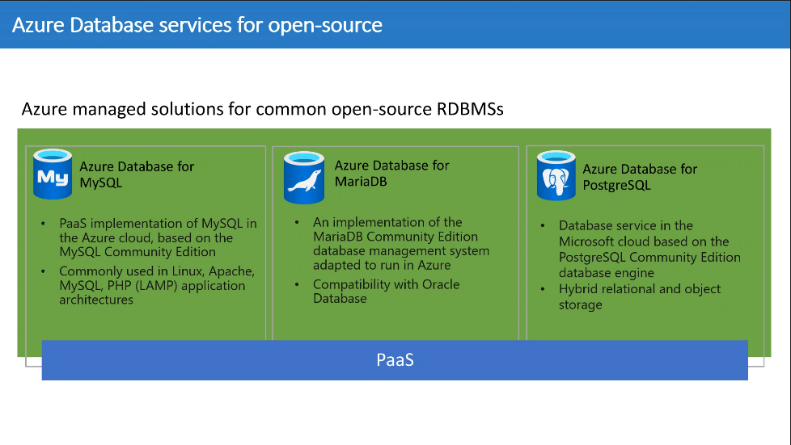

https://www.skillable.com/customer-support/

Link to solve problem with labs in skillable (connection)